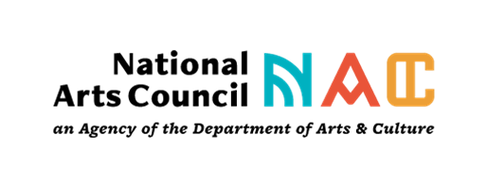

APPLICATION FORM FOR PARTNERSHIPS IN PROVINCES FOR THE DISBURSEMENT OF COVID-19 RELIEF FUNDING

It is compulsory to fully complete all relevant sections of this application form
IMPORTANT INFORMATION FOR APPLICANTS

- This form serves the purpose of identifying organisations that can assist the NAC through a partnership to disburse COVID-19 relief funding to targeted Provinces
- The NAC is looking at collaborating with up to four (4) organisations in each province.
- The applicant may need to demonstrate capacity to disburse funding in more than one district. The allocation per artists for relief is R5 000,00 once off.
- Based on the information you provide in this form, the NAC adjudication panel will decide whether the NAC will be partnering with your organisation to disburse COVID-19 relief funding.
- Note that the completion of this form is not a guarantee of a partnership with the NAC.
- Note that should you be selected to partner with the NAC on the disbursement of relief funding you will be required to sign a contract and thereafter to provide monthly reports on your progress to the NAC.
- The NAC shall cover the administration costs of distributing the funding at 5% of the allocation.

SELECTION CRITERIA

- Organisations and companies that have operated for 5 years or more, as evidenced by registration documentation with an excellent record of accomplishment of implementing arts project are eligible.
- Two consecutive years of Annual Audited Financial Statements will be required. Grants will be made at the discretion of Council in line with the mandate of NAC and its NAC five-year strategic objectives.
- The grant will be for one year only. The funding should be disbursed by 30 September 2021.
- It is COMPULSORY TO COMPLETE all the relevant sections of the application form.
- Ensure that all compulsory documents are included in your application. Please note that incomplete applications will not be considered.
- Submit names and contact details of the management team and their certified ID copies.

ASSESSMENT CRITERIA

The following criteria will be applicable to all applications:
- The profile and track record of the organisation in implementing arts projects.
- Appropriate financial controls, effective governance and management structures are in place.
- Ability to comply with all NAC administrative requirements
- Clear and detailed plan with time lines on how the process of disbursement of relief funds would be implemented
- Detailed explanation on how the awareness of Covid-19 relief funds would be created.
- Demonstrate the ability to present creative and innovative work on digital platforms.

CHECKLIST

Organisation /company

1. Certified copies of SA ID’s of at least 2 office bearers of the organisation (Chairperson/ CEO/ Treasurer)

2. Original valid tax clearance certificate

3. Latest/recent organisations original banks statement (1 month old, stamped) NB: Bank statement must have the name of applicant or organisation on the letterhead of the bank. Do not submit proof of bank account at this stage.

4. Certified copy of the organisation’s registration certificate.

5. Two (2) Latest annual financial statements

6. CV’s of the management team

7. Examples of your organisation’s previous works in the form of photographs, brochures or other published/printed materials

8. Two (2) most recent letters of reference (signed and dated) from other arts organisations, artists and/or community leaders (including their full address and contact details) validating your work in this area.
(Not older than 12 months) to be dated and signed.

